1. **Find factorial using function**

#include <iostream>

using namespace std;

int factorial(int n) {

if (n <= 1) { // Base case: factorial of 0 or 1 is 1

return 1;

}

return n * factorial(n - 1); // Recursive case

}

int main() {

int number;

cout << "Enter a positive integer: ";

cin >> number;

if (number < 0) {

cout << "Factorial is not defined for negative numbers." << endl;

} else {

int result = factorial(number);

cout << "Factorial of " << number << " is " << result << endl;

}

return 0;

}

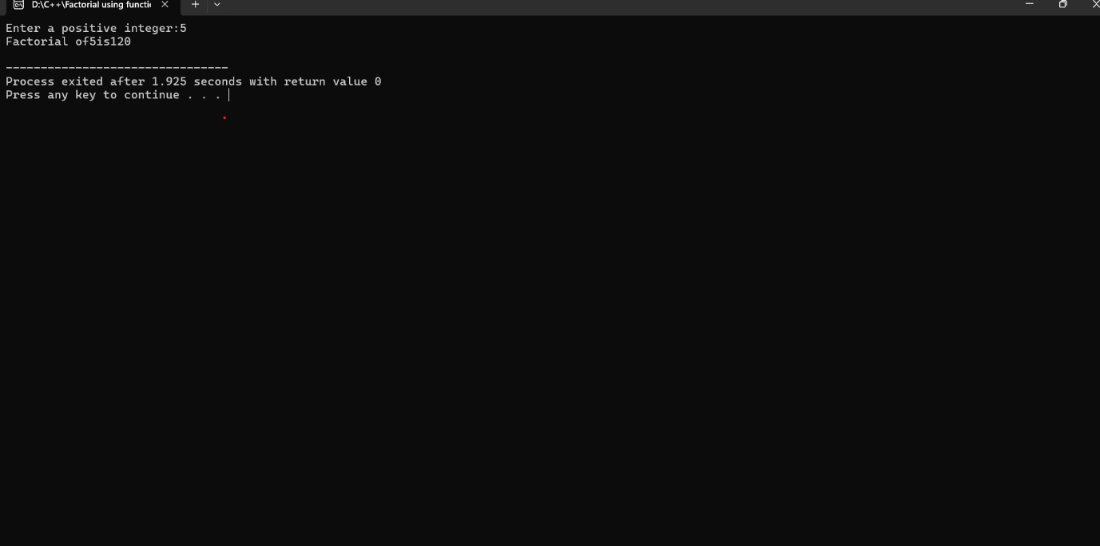

1. **Find prime number using function**

#include <iostream>

using namespace std;

bool isPrime(int n) {

if (n <= 1) return false;

if (n == 2 || n == 3) return true;

if (n % 2 == 0 || n % 3 == 0) return false;

for (int i = 5; i * i <= n; i += 6) {

if (n % i == 0 || n % (i + 2) == 0) return false;

}

return true;

}

int main() {

int number;

cout << "Enter a number: ";

cin >> number;

if (isPrime(number)) {

cout << number << " is a prime number." << endl;

} else {

cout << number << " is not a prime number." << endl;

}

return 0;

}

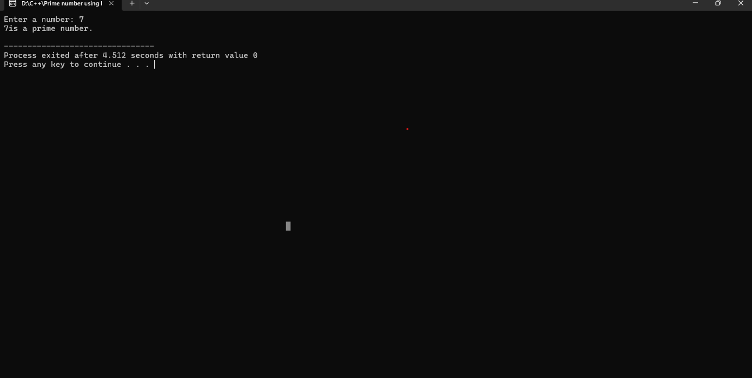

1. **Find the reverse of a string using function**

#include <iostream>

#include <algorithm>

using namespace std;

string reverseString(string str) {

reverse(str.begin(), str.end());

return str;

}

int main() {

string input;

cout << "Enter a string: ";

getline(cin, input);

cout << "Reversed string: " << reverseString(input) << endl;

return 0;

}

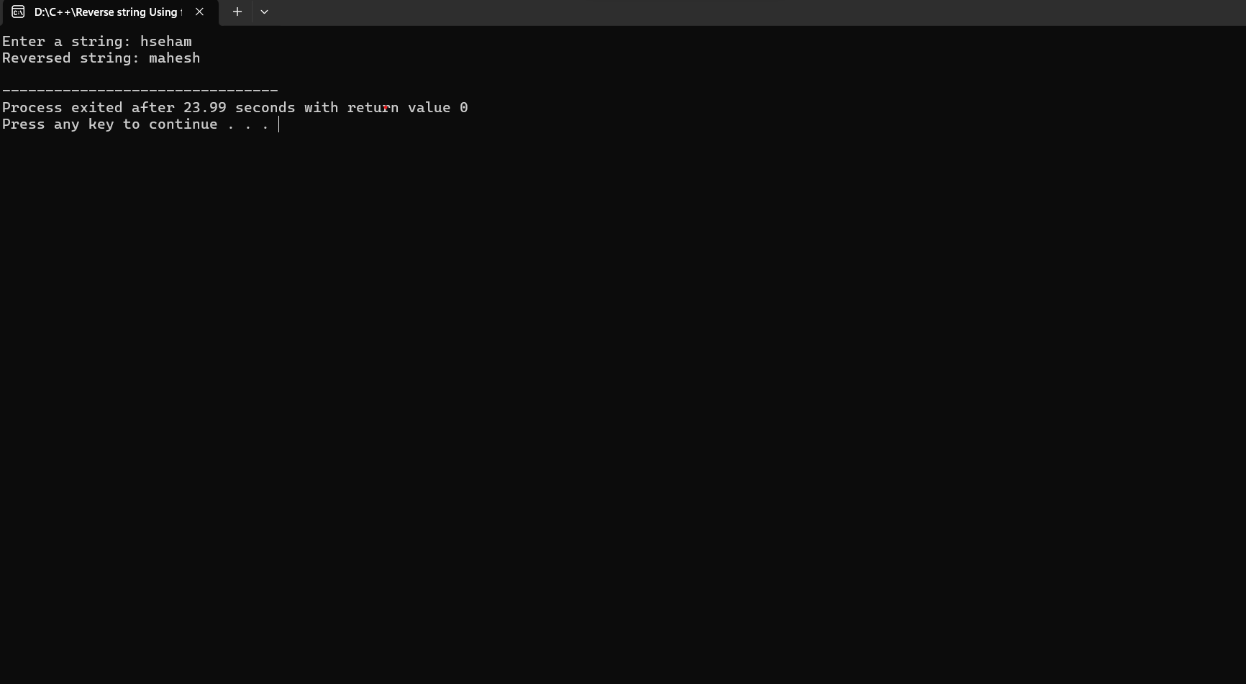

1. **Find minimum and maximum element in an array using function**

#include <iostream>

#include <limits>

using namespace std;

void findMinMax(const int arr[], int size, int& min, int& max) {

min = numeric_limits<int>::max();

max = numeric_limits<int>::min();

for (int i = 0; i < size; ++i) {

if (arr[i] < min) {

min = arr[i];

}

if (arr[i] > max) {

max = arr[i];

}

}

}

int main() {

int n;

cout << "Enter the number of elements in the array: ";

cin >> n;

int arr[n];

cout << "Enter the elements of the array: ";

for (int i = 0; i < n; ++i) {

cin >> arr[i];

}

int min, max;

findMinMax(arr, n, min, max);

cout << "Minimum element: " << min << endl;

cout << "Maximum element: " << max << endl;

return 0;

}

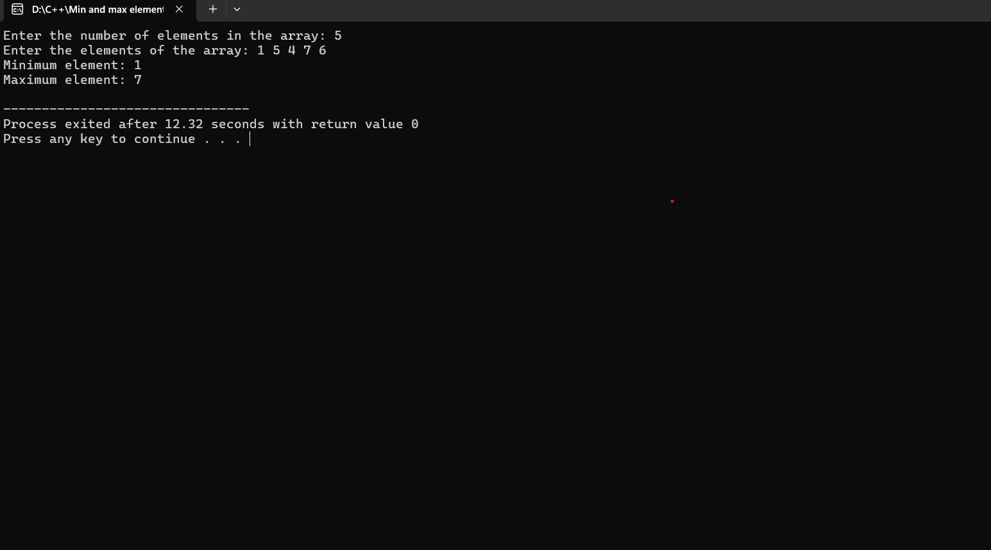

1. **Find GCD of two number using function**

#include <iostream>

using namespace std;

int gcd(int a, int b) {

while (b != 0) {

int temp = b;

b = a % b;

a = temp;

}

return a;

}

int main() {

int num1, num2;

cout << "Enter two numbers: ";

cin >> num1 >> num2;

int result = gcd(num1, num2);

cout << "GCD of " << num1 << " and " << num2 << " is: " << result << endl;

return 0;

}

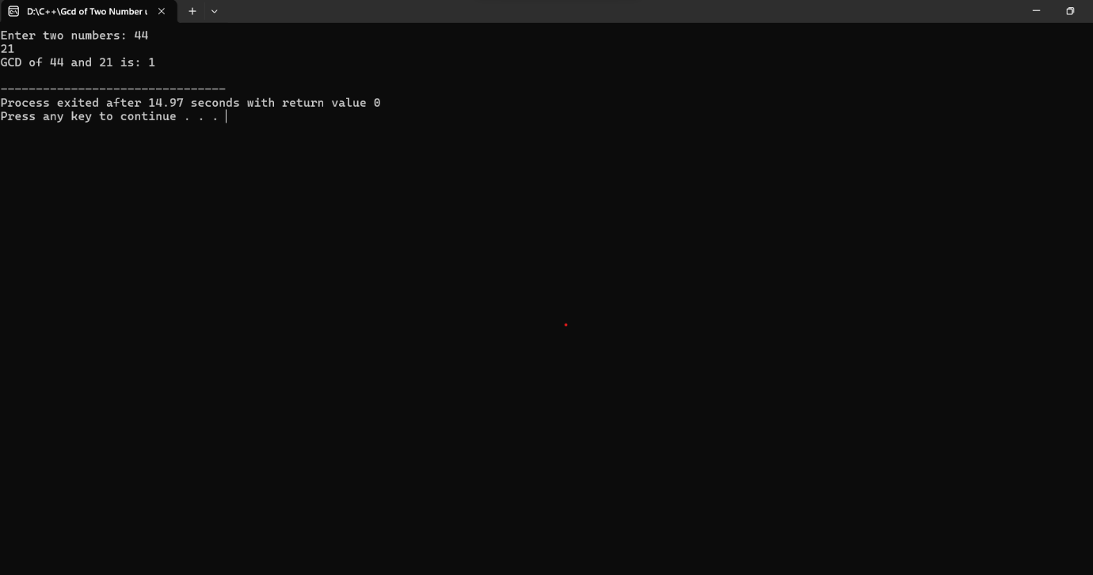

1. **Function to count the no of elements in a string**

#include <iostream>

#include <string>

using namespace std;

int countCharacters(const string& str) {

return str.length();

}

int main() {

string input;

cout << "Enter a string: ";

getline(cin, input);

int count = countCharacters(input);

cout << "The number of characters in the string is: " << count << endl;

return 0;

}

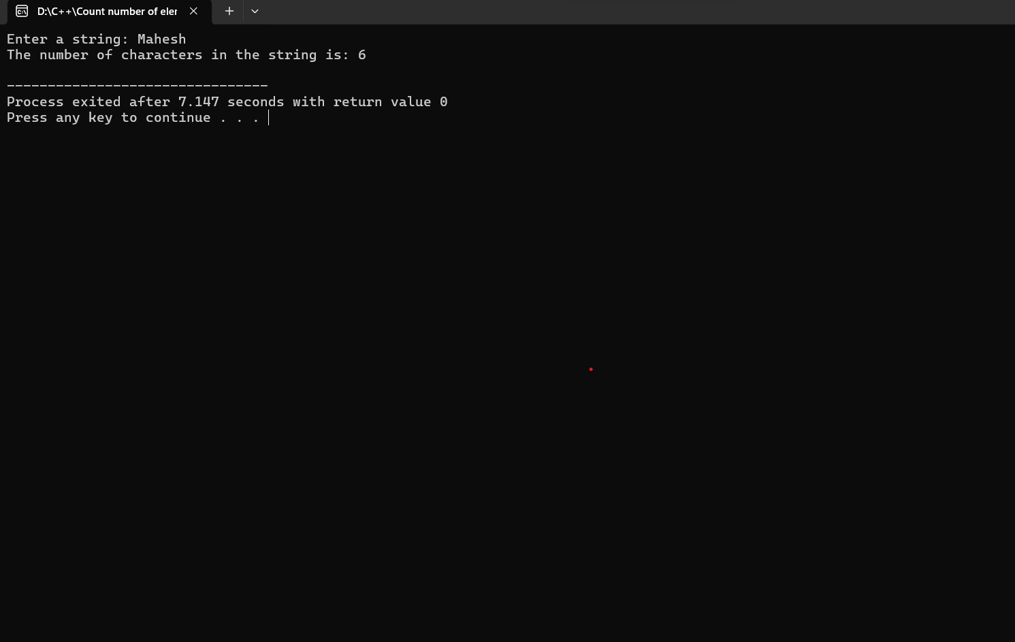

1. **Convert Celsius and Fahrenheit using function**

#include <iostream>

using namespace std;

double celsiusToFahrenheit(double celsius) {

return (celsius * 9.0 / 5.0) + 32.0;

}

double fahrenheitToCelsius(double fahrenheit) {

return (fahrenheit - 32.0) * 5.0 / 9.0;

}

int main() {

double temp;

char choice;

cout << "Enter 'C' to convert from Celsius to Fahrenheit or 'F' to convert from Fahrenheit to Celsius: ";

cin >> choice;

if (choice == 'C' || choice == 'c') {

cout << "Enter temperature in Celsius: ";

cin >> temp;

cout << "Temperature in Fahrenheit: " << celsiusToFahrenheit(temp) << endl;

} else if (choice == 'F' || choice == 'f') {

cout << "Enter temperature in Fahrenheit: ";

cin >> temp;

cout << "Temperature in Celsius: " << fahrenheitToCelsius(temp) << endl;

} else {

cout << "Invalid choice!" << endl;

}

return 0;

}

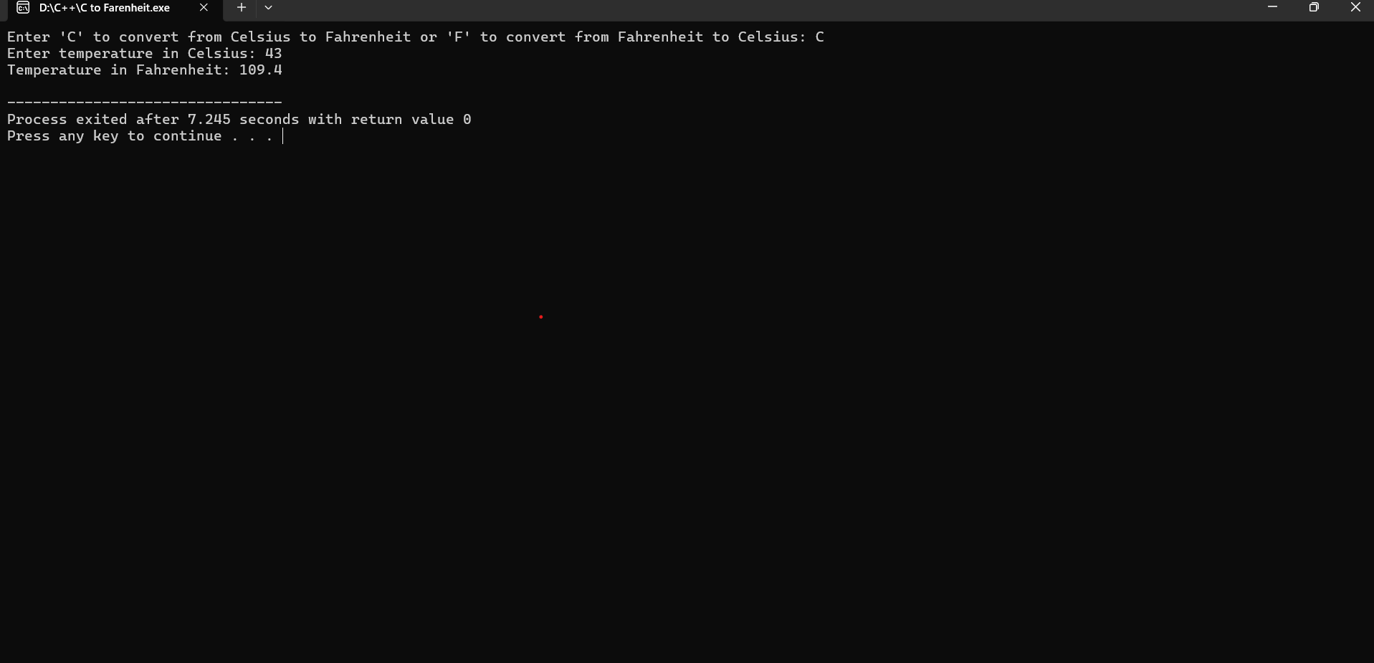

1. **Find the area of a circle using function**

#include <iostream>

#include <cmath>

using namespace std;

double calculateArea(double radius) {

return M_PI * radius * radius;

}

int main() {

double radius;

cout << "Enter the radius of the circle: ";

cin >> radius;

double area = calculateArea(radius);

cout << "The area of the circle is: " << area << endl;

return 0;

}

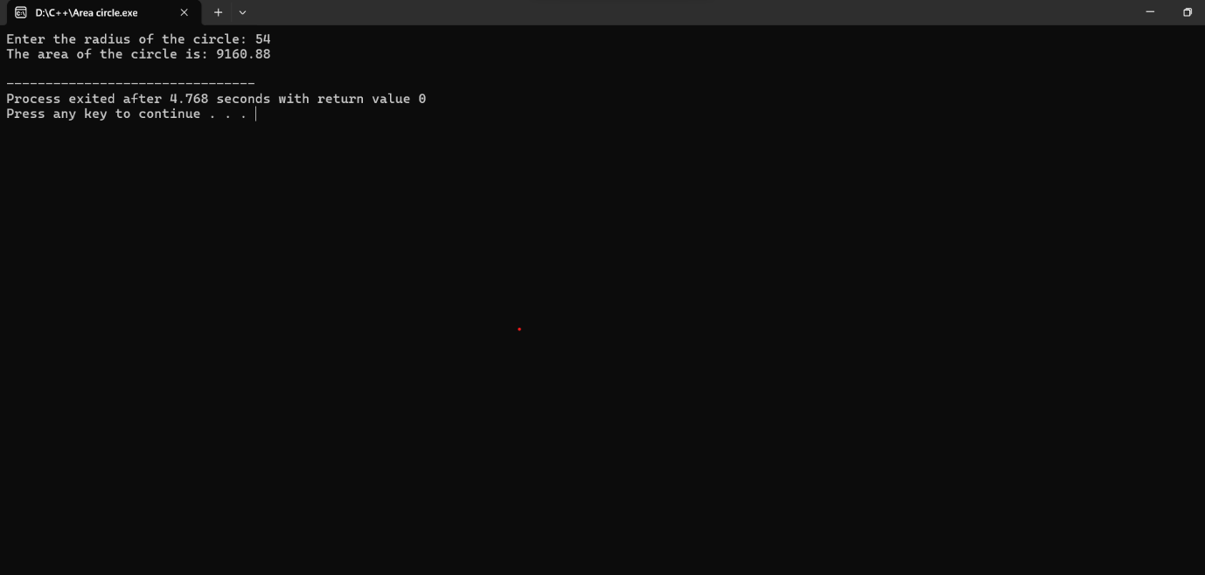

1. **Check whether the string is palindrome or not**

#include <iostream>

#include <string>

#include <algorithm>

using namespace std;

bool isPalindrome(const string& str) {

string reversed = str;

reverse(reversed.begin(), reversed.end());

return str == reversed;

}

int main() {

string input;

cout << "Enter a string: ";

getline(cin, input);

if (isPalindrome(input)) {

cout << "\"" << input << "\" is a palindrome." << endl;

} else {

cout << "\"" << input << "\" is not a palindrome." << endl;

}

return 0;

}

